SWIFT SHIP TRACKER
A Real-Time Web-Based System for Shipment Tracking and Fleet Management
A PROJECT REPORT
Submitted in partial fulfilment of the requirements for the project component of the academic curriculum
Submitted by:
Name : K. Anusiya
Register number : 820723205003
Department : B.Tech information technology
College name : As salam college of engineering and technology
Academic year : 2026_ 2027

ACKNOWLEDGEMENT
I would like to express my sincere gratitude to my project guide, [Guide Name], for the continuous support, patience, and valuable guidance extended throughout the duration of this project. Their insight into software engineering and web application design was instrumental in shaping the direction of this work.
I am also thankful to the Head of the Department, [HOD Name], and all the faculty members of the Department of [Department Name] for providing the laboratory facilities and encouragement needed to complete this project.
I extend my appreciation to my family and friends for their constant encouragement and support, and to my classmates who tested the system and shared useful feedback during development.
Finally, I acknowledge the open-source community, whose freely available libraries, documentation, and tools, including React, Node.js, SQLite, Socket.IO, Leaflet, and OpenStreetMap, made it possible to build this project without any licence cost and without compromising on core functionality.

ABSTRACT
Moving goods by sea and land involves many parties, and the information about where a shipment is and when it will arrive is usually scattered across emails, phone calls, and spreadsheets. Customers must contact staff for every update, delays are noticed late, and there is no reliable time-stamped history. Commercial tracking platforms solve these problems but are generally subscription-based and closed, which puts them out of reach for small operators, students, and training institutions. This project presents the design, development, and testing of Swift Ship Tracker, a low-cost, web-based shipment tracking and fleet management system built entirely with free and open-source technologies.
The system is built with a React front end, a Node.js and Express back end, an SQLite database, and Socket.IO for real-time communication. Maps are displayed using Leaflet and OpenStreetMap, which need no paid key. Three types of users are supported: administrators, registered customers, and public visitors. Administrators create shipments, each of which receives a unique tracking ID, and manage vessels, statuses, and reports. Customers see their own shipments and receive notifications. Any visitor can enter a tracking ID to see the status, the route, the estimated time of arrival, a status timeline, and a marker that moves live on the map without refreshing the page.
A built-in GPS simulator moves shipments along predefined routes so that the live tracking behaviour can be demonstrated without hardware. The server calculates the estimated time of arrival from the remaining distance and the average speed, and automatically flags a shipment as delayed when it falls behind schedule. The administrative dashboard provides summary cards, charts, searchable shipment tables, an activity log, CSV export, and a QR code for every shipment. Security is provided through hashed passwords, token-based authentication, role-based access control, input validation, and rate limiting.
The project demonstrates that a complete, professional tracking platform can be built at essentially zero licence cost and run on an ordinary laptop. The report concludes with a discussion of the limitations, mainly the use of simulated positions and in-app notifications, and a roadmap that includes real GPS and AIS integration, email and SMS alerts, machine-learning-based delay prediction, and a mobile application.
Keywords: Shipment tracking, logistics, real-time web application, React, Node.js, Socket.IO, Leaflet, OpenStreetMap, fleet management, estimated time of arrival.

TABLE OF CONTENTS
Chapter 1: Introduction 5
Chapter 2: Literature Review 8
Chapter 3: System Analysis and Feasibility Study 10
Chapter 4: System Design and Architecture 13
Chapter 5: Hardware and Software Requirements 17
Chapter 6: Implementation and Methodology 19
Chapter 7: Low-Cost Analysis 21
Chapter 8: Testing and Validation 23
Chapter 9: Results and Discussion 25
Chapter 10: Advantages, Limitations and Applications 27
Chapter 11: Future Scope 28
Chapter 12: Conclusion 29
Chapter 13: References 30
Appendix A: Sample Source Code 31

CHAPTER 1: INTRODUCTION

1.1 Background
Global trade depends on the reliable movement of goods. A very large share of the world's cargo travels by sea, and almost every consumer product, from electronics to food and medicines, spends part of its journey inside a container on a ship. For the businesses that send and receive these goods, the most important question after "has it been dispatched?" is "where is it now, and when will it arrive?".
In practice, the answer to this question is often difficult to obtain. A shipment typically passes through several hands: the sender, a freight forwarder, a shipping line, port and customs authorities, a road or rail carrier, and finally the receiver. Each party maintains its own records, and status information is commonly passed along by phone calls, emails, and spreadsheets. A customer who wants a simple update may have to contact several people, and the answer is often hours or days old by the time it arrives.
Modern web technologies make it possible to close this information gap at very low cost. Browser-based maps, real-time communication between server and client, and lightweight databases allow a small team, or a single student developer, to build a tracking platform that shows the position and status of a shipment live on a map, calculates an estimated time of arrival, and notifies the customer automatically when something changes. This project, Swift Ship Tracker, is built on that idea.

1.2 Problem Statement
Shipment tracking in small and medium logistics businesses is still largely manual, fragmented, and reactive. The following concrete problems motivate this project:
- Status information is scattered across emails, phone calls, and spreadsheets, so no single source of truth exists for a shipment's current state.
- Customers cannot check progress themselves; they must contact the operator, which increases workload and delays responses.
- Delays are discovered late, because nothing compares the planned arrival time with the actual progress of the shipment.
- There is no consistent, time-stamped history of events for each shipment, which makes disputes and audits difficult.
- Commercial tracking platforms exist, but they are usually subscription-based, closed, and priced for large enterprises, which puts them out of reach for small operators, students, and training institutions.
The central problem this project addresses is therefore: how can a small logistics operator provide customers with live, self-service shipment tracking and give staff a single dashboard to manage shipments and vessels, using only free and open-source technologies?

1.3 Objectives of the Project
- To design and develop a web-based shipment tracking system with separate access for administrators, registered customers, and public visitors.
- To generate a unique tracking ID for every shipment and allow anyone holding that ID to view its status, route, and history without logging in.
- To display the shipment position on an interactive map and update it in real time without the user refreshing the page.
- To record every status change as a time-stamped event, producing a complete shipment timeline.
- To calculate an estimated time of arrival (ETA) and automatically flag shipments that are running late.
- To provide an administrative dashboard with shipment, vessel, and activity management, charts, and exportable reports.
- To keep the total cost of building and running the system at or near zero by using only free, open-source tools and services.

1.4 Scope of the Project
The scope of this project covers the analysis, design, implementation, and testing of a complete web application. It includes user registration and login with role-based access, shipment creation and management, public tracking by tracking ID, live map tracking, status timeline, ETA calculation, notifications, fleet management, reports, and an audit log of administrative actions.
Vessel and vehicle positions in the demonstration system are produced by a built-in GPS simulator that moves shipments along predefined routes. The project does not include integration with physical GPS hardware, live AIS (Automatic Identification System) feeds, or payment and billing. The design, however, separates the location source from the rest of the system, so a real GPS or AIS feed can be connected later without changing the application logic; this is described in Chapter 11.

1.5 Significance of a Low-Cost, Open-Source Design
A recurring theme of this report is that every technology choice was made with cost and accessibility in mind. The map is based on OpenStreetMap through the Leaflet library, which needs no paid API key. The database is SQLite, which needs no separate database server. The front end uses React and the back end uses Node.js, both free and widely documented. As a result, the whole system can be installed and run on an ordinary laptop with two commands, and it can be hosted on a free cloud tier for demonstration.
This approach has a practical benefit beyond cost. A tracking platform that anyone can download, run, and modify is suitable for adoption by small logistics firms, training institutes, and student teams who want to study how a real-time logistics application is built.

1.6 Organisation of the Report
Chapter 2 reviews existing literature and technologies related to shipment tracking. Chapter 3 presents the system analysis, including the feasibility study and requirements. Chapter 4 describes the system architecture and design diagrams. Chapter 5 lists the hardware and software requirements. Chapter 6 explains the implementation and methodology. Chapter 7 presents the cost analysis. Chapter 8 covers testing and validation. Chapter 9 presents the results and discussion. Chapter 10 discusses advantages, limitations, and applications. Chapter 11 outlines future scope, followed by the conclusion, references, and an appendix containing sample source code.

CHAPTER 2: LITERATURE REVIEW
This chapter reviews existing practice and technology relevant to the project across four areas: traditional shipment tracking, positioning technologies used in logistics, commercial tracking platforms, and the web technologies that make real-time tracking possible. The purpose is to identify the gap that Swift Ship Tracker fills.

2.1 Traditional Shipment Tracking
Traditionally, shipment status has been communicated through documents and messages: the bill of lading, the cargo manifest, delivery notes, and email or telephone updates from the carrier. Small operators frequently keep this information in spreadsheets. While this approach is cheap and familiar, it is manual, error-prone, and gives the customer no direct visibility. Information is only as current as the last person who updated it.

2.2 Positioning Technologies in Logistics
Two positioning technologies dominate modern tracking. The Global Positioning System (GPS) lets a receiver compute its latitude and longitude from satellite signals, and is widely used in trucks, containers, and handheld trackers. At sea, vessels above a certain size are required to carry an Automatic Identification System (AIS) transponder, which broadcasts the ship's identity, position, speed, and heading to nearby vessels and shore stations.
Both technologies deliver a stream of position reports. What a tracking application must do with that stream is the same in either case: store the latest position, add it to the history, compare progress with the plan, and present it to the user. This observation justifies the design decision in this project to treat the location source as a replaceable component.

2.3 Commercial Tracking Platforms
A range of commercial platforms provides container and parcel tracking, usually as subscription services accessed through a web dashboard or an API. These platforms are mature and feature-rich, but they have limitations for small users: recurring subscription cost, limited ability to customise workflows, dependence on a third party for data, and a level of complexity that exceeds the needs of a small operator or a teaching environment.

2.4 Web Technologies for Real-Time Tracking
Several open technologies now make it straightforward to build tracking applications. Leaflet is a lightweight open-source JavaScript library for interactive maps, and OpenStreetMap provides freely usable map data. The WebSocket protocol (RFC 6455) allows a server to push data to a browser the moment it changes, and libraries such as Socket.IO make this simple to use. JSON Web Tokens (RFC 7519) provide a compact, standard way to authenticate users in a stateless web API. React supports building responsive user interfaces as reusable components, and Node.js with Express supports building a REST API in the same language as the front end.

2.5 Research Gap and Positioning of This Project
Reviewing these areas together shows a clear gap. Manual tracking is cheap but not live or self-service. Commercial platforms are live but costly, closed, and oversized for small users. The open web technologies needed to build a live tracker are mature, but they are rarely packaged together into a complete, role-based, easy-to-run tracking system that includes fleet management, notifications, and reporting.
Swift Ship Tracker positions itself in this gap. It combines free, open-source building blocks into a complete application that offers the core features of a commercial tracker, namely live map, timeline, ETA, alerts, and dashboards, at no licence cost and with full access to the source code.

CHAPTER 3: SYSTEM ANALYSIS AND FEASIBILITY STUDY

3.1 Existing System
In the existing system, a staff member receives updates about a shipment from the carrier or port by phone or email and records them in a spreadsheet or register. When a customer asks about a consignment, the staff member looks up the entry or contacts the carrier again and replies manually. Delays are noticed only when the customer complains or the planned date passes.
This workflow has three structural weaknesses: the information is not live, the customer depends on staff for every query, and there is no automatic comparison between planned and actual progress.

3.2 Proposed System
The proposed system replaces the manual workflow with a central web application. Administrators create shipments, which receive a unique tracking ID. As the shipment moves, its location and status are updated, either by an administrator or by the GPS simulator, and every update is stored as a time-stamped event. Customers and public visitors enter the tracking ID to see the current status, a live map position, the route, the ETA, and the full timeline. The server calculates the ETA continuously and marks a shipment as delayed when it falls behind schedule, and the customer is notified in the application when the status changes.
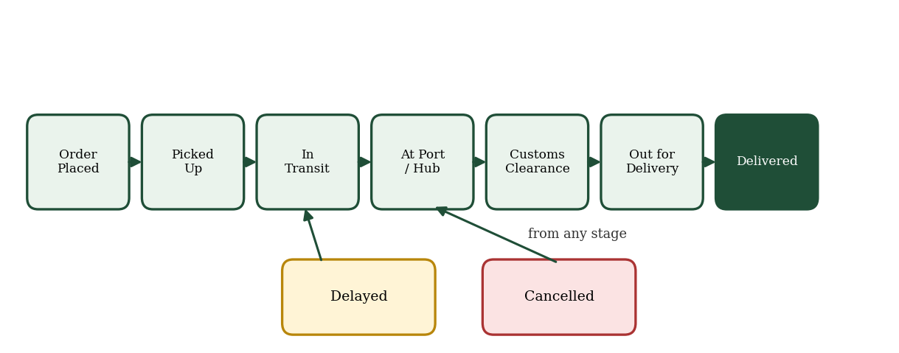
Fig 3.1: Shipment status lifecycle used by the proposed system.

3.3 Comparison of Existing and Proposed System
Table 3.1: Comparison of existing and proposed systems
Aspect | Existing (Manual) System | Proposed System
Status updates | Phone, email, spreadsheet | Central database, updated in real time
Customer access | Must contact staff | Self-service tracking by ID, 24x7
Location visibility | None or text description | Live marker and route on an interactive map
Delay detection | Noticed late, manually | Automatic ETA check and delay flag
History / audit | Incomplete, scattered | Time-stamped event log and activity log
Reporting | Manual compilation | Dashboard charts and CSV export
Cost | Staff time | Free, open-source software stack

3.4 Feasibility Study

3.4.1 Technical Feasibility
All technologies used are mature, well documented, and free: React, Node.js, Express, SQLite, Socket.IO, Leaflet, and OpenStreetMap. The development can be completed on a standard laptop, and the application runs in an ordinary web browser. The project is therefore technically feasible.

3.4.2 Economic Feasibility
No licence fees are required, no paid map or database service is used, and the system can run on a free hosting tier for demonstration. The only real cost is development time. The project is therefore economically feasible; a detailed breakdown is given in Chapter 7.

3.4.3 Operational Feasibility
The interface follows familiar web conventions (a search box, tables, a map, and a timeline), so staff and customers need little or no training. The role-based design keeps each user's screen limited to what is relevant to them. The system is therefore operationally feasible.

3.5 Requirement Analysis

3.5.1 Functional Requirements
Table 3.2: Functional requirements
ID | Module | Requirement
FR1 | Authentication | Users can register, log in, and log out; passwords are stored hashed; access depends on role.
FR2 | Shipment management | Admin can create, edit, delete, and search shipments; a unique tracking ID is generated automatically.
FR3 | Public tracking | Any visitor can enter a tracking ID and view status, map position, route, ETA, and history.
FR4 | Live map | The shipment marker moves on the map in real time as location updates arrive.
FR5 | Status timeline | Each status change is stored with time and location and shown as a timeline.
FR6 | ETA and delay | The system estimates arrival time and flags delayed shipments automatically.
FR7 | Notifications | Customers receive an in-app notification when their shipment status changes.
FR8 | Fleet management | Admin can add and edit vessels and assign them to shipments.
FR9 | Dashboard | Admin sees totals, status distribution, monthly shipments, and recent activity.
FR10 | Reports and receipts | Admin can export shipments to CSV; a shipment receipt can be downloaded as PDF.
FR11 | QR code | Each shipment has a QR code that opens its public tracking page.
FR12 | Audit log | Administrative actions are recorded with user and time.

3.5.2 Non-Functional Requirements
- Usability: clear, responsive interface that works on mobile, tablet, and desktop screens.
- Performance: pages and tracking lookups should respond quickly under normal classroom or demonstration load.
- Security: hashed passwords, token-based authentication, input validation, rate limiting, and role-based access control.
- Reliability: data persists in the database; a server restart must not lose shipment history.
- Maintainability: modular code organised into routes, controllers, and middleware, with comments for explanation.
- Portability: runs on Windows, macOS, and Linux with Node.js installed.

CHAPTER 4: SYSTEM DESIGN AND ARCHITECTURE

4.1 System Architecture Overview
Swift Ship Tracker follows a three-tier architecture. The presentation tier is a React single-page application running in the user's browser. The application tier is a Node.js server that exposes a REST API, enforces authentication and authorisation, runs the tracking engine, and pushes real-time updates through Socket.IO. The data tier is an SQLite database that stores users, shipments, vessels, tracking events, notifications, and the activity log.
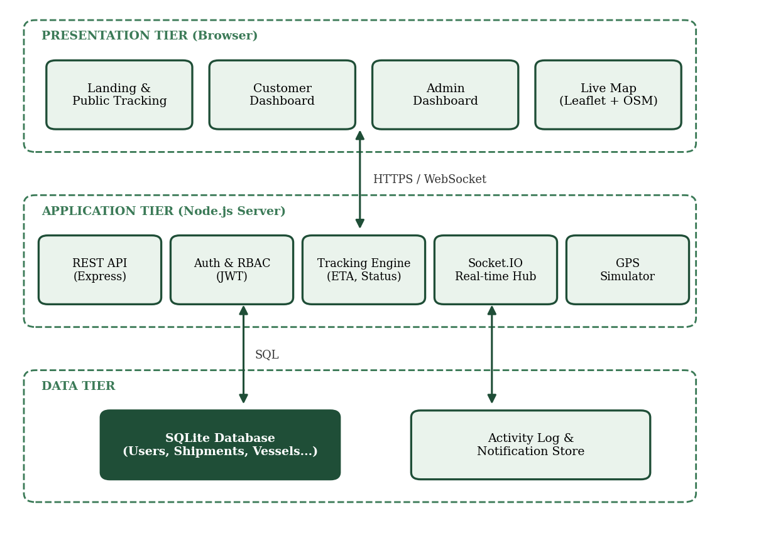
Fig 4.1: System architecture - three-tier overview (Presentation, Application, Data).
The browser communicates with the server over HTTPS for ordinary requests and over a WebSocket connection for live updates. The map tiles are fetched directly from the OpenStreetMap tile servers and need no key.

4.2 Database Design
The database is normalised so that each fact is stored once. A user can own many shipments; a vessel can carry many shipments; and each shipment has many tracking events that form its timeline. Notifications and activity log entries refer to the user they belong to.
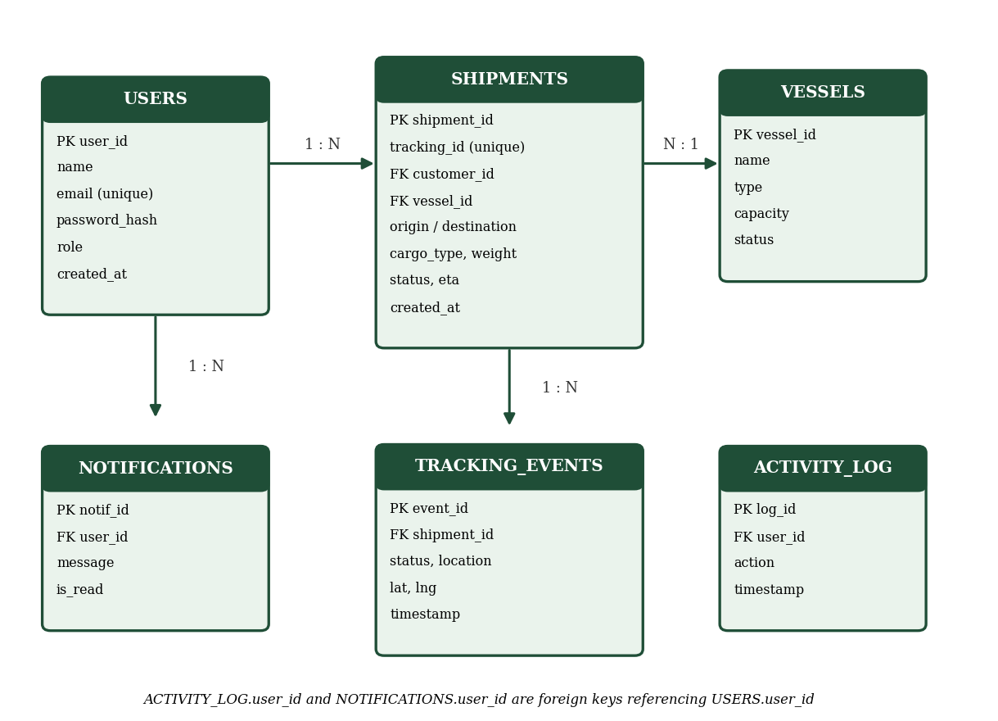
Fig 4.2: Entity-relationship diagram of Swift Ship Tracker.
Table 4.1: Database tables
Table | Purpose and key fields
users | Registered accounts: user_id, name, email (unique), password_hash, role (admin / customer), created_at.
vessels | Fleet records: vessel_id, name, type, capacity, status (available / assigned / maintenance).
shipments | Main record: shipment_id, tracking_id (unique), customer_id, vessel_id, origin, destination, cargo_type, weight, status, eta, current latitude and longitude.
tracking_events | Timeline entries: event_id, shipment_id, status, location name, latitude, longitude, timestamp.
notifications | In-app alerts: notif_id, user_id, message, is_read, created_at.
activity_log | Audit trail: log_id, user_id, action, timestamp.

4.3 Data Flow Diagram
The Level 0 (context) diagram shows the system as a single process interacting with four external entities. The administrator sends shipment and vessel data and receives dashboards and reports. The customer receives shipment details and notifications. The public visitor submits a tracking ID and receives tracking information. The GPS simulator (or a real device in future) supplies location updates.
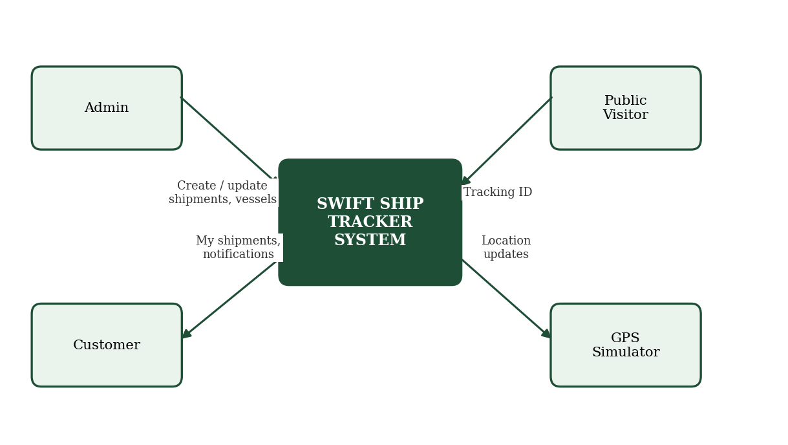
Fig 4.3: Level 0 data flow diagram of Swift Ship Tracker.

4.4 Use Case Diagram
Three actors use the system. The Admin has full control over shipments, vessels, status updates, dashboards, and the activity log. The Customer can view his or her own shipments, download receipts, and receive notifications. The Public Visitor can only track a shipment by its ID and view the live map.
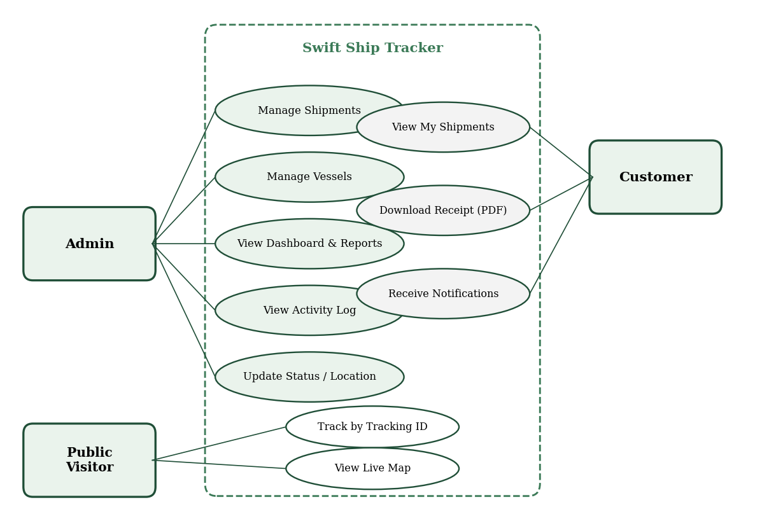
Fig 4.4: Use case diagram - Admin, Customer, and Public Visitor.

4.5 Deployment Diagram
In deployment, client devices (laptops or phones) connect to a single Node.js server that hosts the REST API, the Socket.IO hub, and the GPS simulator. The server reads and writes an SQLite database file. Map tiles come directly from OpenStreetMap.
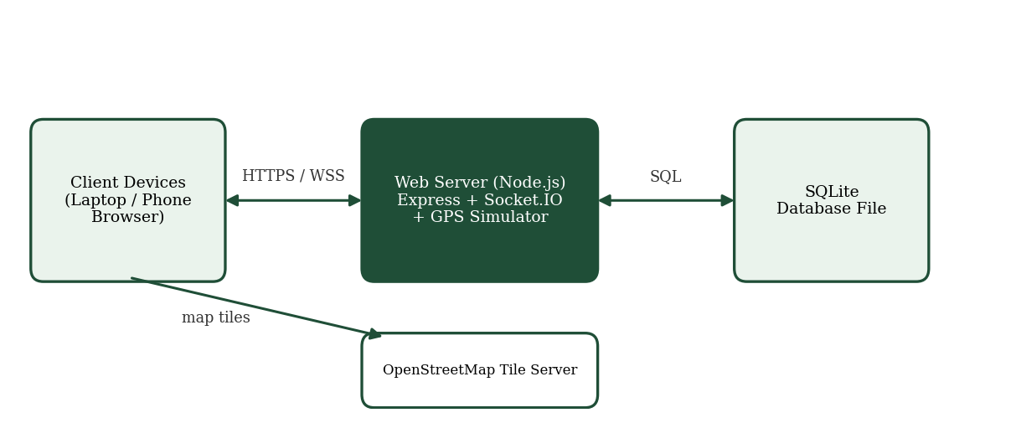
Fig 4.5: Deployment diagram - client devices, server, database, and map tile service.

4.6 API Design
Table 4.2: Main REST API endpoints
Method | Endpoint | Access | Description
POST | /api/auth/register | Public | Create a customer account
POST | /api/auth/login | Public | Log in and receive a JWT
GET | /api/track/:trackingId | Public | Status, route, ETA, and timeline
GET | /api/shipments | Auth | List shipments (own or all for admin)
POST | /api/shipments | Admin | Create a shipment
PUT | /api/shipments/:id | Admin | Edit shipment or update status
DELETE | /api/shipments/:id | Admin | Delete a shipment
GET/POST | /api/vessels | Admin | List or add vessels
GET | /api/notifications | Auth | List my notifications
GET | /api/dashboard/stats | Admin | Totals and chart data
GET | /api/reports/shipments.csv | Admin | Export shipments as CSV

CHAPTER 5: HARDWARE AND SOFTWARE REQUIREMENTS

5.1 Hardware Components
Because Swift Ship Tracker is a software system, it needs no special hardware. An ordinary computer is sufficient for development and for running the server, and any device with a web browser can be used as a client.
Table 5.1: Hardware requirements
Component | Requirement
Development computer | Laptop or desktop, 64-bit, Windows 10/11, macOS, or Linux
Processor and memory | Dual-core processor or better; 4 GB RAM minimum, 8 GB recommended
Storage | At least 2 GB free for tools, dependencies, and database
Network | Internet connection for installing packages and loading map tiles
Client device | Any modern phone, tablet, or computer with a web browser

5.2 Software and Tools
Table 5.2: Software and tools
Layer | Technology | Purpose
Front end | React with Vite | Component-based user interface and fast development build
Styling | Tailwind CSS | Responsive layout, light and dark theme
Maps | Leaflet and OpenStreetMap | Interactive map, markers, and route line
Charts | Recharts | Dashboard charts
Back end | Node.js and Express | REST API and business logic
Real time | Socket.IO | Push live location and status to browsers
Database | SQLite | Embedded relational database with no separate server
Security | JWT, bcrypt, helmet, rate limiting | Authentication, password hashing, and request protection
Development tools | VS Code, Git, Postman, AI coding assistant | Editing, version control, API testing, and code generation

5.3 Minimum System Requirements (Development Workstation)
- Node.js (current LTS version) and npm installed.
- A modern web browser such as Chrome, Edge, or Firefox.
- A code editor such as Visual Studio Code.
- Git for version control (recommended).
- A terminal for running the install, seed, and start commands.

5.4 Justification of Component Selection
React and Vite were chosen because they are widely used, well documented, and allow the interface to be built from small reusable components. Node.js and Express allow the same language, JavaScript, to be used on both client and server, which reduces the learning load. SQLite was preferred to a client-server database because it requires no installation or configuration, and its single-file format makes the project easy to copy, submit, and demonstrate.
Leaflet with OpenStreetMap gives full map functionality with no API key or billing account, which removes both cost and a common point of failure during demonstrations. Socket.IO provides reliable real-time messaging with automatic reconnection and a fallback when WebSockets are unavailable.

CHAPTER 6: IMPLEMENTATION AND METHODOLOGY

6.1 Overall Methodology
The project followed an iterative, incremental approach. The work was divided into small stages, each delivering a working part of the system, which was then tested before the next stage began:
- Requirement gathering and design of the database and API.
- Authentication, user roles, and protected routes.
- Shipment creation, tracking ID generation, and the public tracking page.
- Map display, status timeline, and real-time updates with Socket.IO.
- GPS simulation, ETA calculation, and delay detection.
- Admin dashboard, fleet management, notifications, reports, QR code, and audit log.
- Testing, fixing, documentation, and preparation of the demonstration data.

6.2 Project Structure
The code is organised into two folders. The server folder contains routes (URL definitions), controllers (the logic behind each route), middleware (authentication, validation, error handling), the database schema and seed script, and the simulator. The client folder contains pages, reusable components, and a small API helper module.
swift-ship-tracker/
server/
src/routes/ auth, shipments, track, vessels, reports
src/controllers/ business logic for each route
src/middleware/ auth (JWT), role check, validation, errors
src/services/ tracking engine, ETA, simulator, notifications
src/db/ schema.sql, database connection, seed.js
src/index.js Express + Socket.IO entry point
client/
src/pages/ Landing, Track, Login, Dashboard, Shipments
src/components/ Map, Timeline, StatCard, Navbar, Toast
src/api.js Axios helper with token handling

6.3 Authentication and Role-Based Access
When a user registers, the password is hashed with bcrypt before being stored; the plain password is never saved. On login, the server verifies the password and returns a signed JSON Web Token containing the user's identifier and role. The client sends this token with every request. A middleware function verifies the token and a second function checks the role, so that, for example, only an administrator can create a shipment.

6.4 Shipment Creation and Tracking ID
When an administrator creates a shipment, the server validates the input, generates a unique tracking ID of the form SST-XXXXXXXX, saves the shipment, and records the first tracking event (Order Placed). The ID uses an unambiguous character set and is checked against the database to guarantee uniqueness. A QR code encoding the public tracking URL is generated for the shipment.

6.5 Live Tracking and GPS Simulation
Every active shipment has a route defined as an ordered list of coordinates between its origin and destination. The simulator runs on a timer on the server. At each tick it advances every in-transit shipment a small distance along its route, saves the new position, appends a tracking event when a milestone is reached, and emits a Socket.IO message to the clients watching that shipment. The browser receives the message and moves the marker on the map without any page reload.
Because the simulator only produces position messages, it can later be replaced by a real GPS or AIS data source without changing the rest of the application.

6.6 ETA Calculation and Delay Detection
The ETA is estimated from the remaining distance and the average speed of the shipment. Remaining distance is computed from the current position to the destination along the route using the haversine formula for distance between two latitude and longitude points. If the estimated arrival is later than the planned delivery date by more than a set tolerance, the shipment status changes to Delayed, a tracking event is recorded, and the customer is notified. If progress recovers, the status returns to In Transit.

6.7 Front-End Implementation
The interface is built from React components. The public Track page contains a search box, a status badge, the Leaflet map, and a vertical timeline. The Admin dashboard shows summary cards, charts drawn with Recharts, a searchable and paginated shipment table, and the activity feed. The layout is responsive and supports a dark theme. Forms validate input on the client and the server, and operations report success or failure through toast messages.

6.8 Deployment and Execution Process
- Install Node.js and extract the project folder.
- Run the install command in the server and client folders to download dependencies.
- Run the seed script to create the administrator, sample customers, vessels, and demonstration shipments.
- Start the server and the client; the application opens in the browser.
- Log in as administrator to manage data, or enter a sample tracking ID on the landing page to see public tracking.

CHAPTER 7: LOW-COST ANALYSIS

7.1 Development Cost Breakdown
Since the project is built entirely from free and open-source components, the monetary cost of development is minimal. The table lists the resources used and their cost. Figures are indicative.
Table 7.1: Development and running cost
Resource | Tool / Service | Cost (INR)
Operating environment | Existing laptop | 0 (already owned)
Front-end framework | React, Vite, Tailwind CSS | 0
Back-end runtime | Node.js, Express | 0
Database | SQLite | 0
Maps | Leaflet, OpenStreetMap | 0
Real-time messaging | Socket.IO | 0
Demonstration hosting | Free cloud hosting tier | 0
Optional custom domain | Domain registrar | Approx. 700 - 1,000 per year (optional)
Total (without optional items) |  | 0

7.2 Comparison with Commercial Alternatives
Table 7.2: Proposed system versus commercial alternatives
Factor | Swift Ship Tracker | Typical commercial platform
Licence model | Free, open source | Recurring subscription
Source code access | Full | None
Customisation | Unlimited; code can be changed | Limited to vendor options
Data ownership | Stored in own database | Held on vendor servers
Setup effort | Two commands after install | Account, onboarding, configuration
Real GPS / AIS data | Planned future extension | Usually included
Scale | Suited to small and medium use | Built for large enterprises

7.3 Return on Investment Consideration
The return from the system comes from time saved and service improved. Each customer enquiry answered by the self-service tracking page is an enquiry staff do not have to handle by phone or email. Automatic delay detection lets the operator warn customers early, which improves trust. Because there is no licence cost, the break-even point is reached as soon as the system replaces even a small amount of manual follow-up work.

CHAPTER 8: TESTING AND VALIDATION

8.1 Testing Strategy
Testing was carried out at three levels. Unit testing checked individual functions such as the tracking ID generator, the distance and ETA calculation, and the password hashing. Integration testing checked that modules work together, for example that creating a shipment through the API produces a database record, a first tracking event, and a notification. System testing checked complete user scenarios from the browser, such as a visitor tracking a shipment while an administrator updates its status.
API endpoints were exercised with Postman, including invalid inputs and requests without a valid token. The interface was checked on desktop and mobile screen sizes and in light and dark themes.

8.2 Unit and Integration Test Cases
The test cases below were defined for the main functions of the system. The last column is completed during testing by recording Pass or Fail together with any remarks.
Table 8.1: Test cases
ID | Module | Test description | Expected result | Status
TC01 | Auth | Register with valid details | Account created; password stored hashed
TC02 | Auth | Register with an existing email | Request rejected with a clear message
TC03 | Auth | Login with wrong password | Login refused; no token issued
TC04 | Auth | Access admin API as a customer | Request rejected (forbidden)
TC05 | Shipment | Create shipment with valid data | Record saved with unique SST- tracking ID
TC06 | Shipment | Create shipment with missing fields | Validation error; nothing saved
TC07 | Tracking | Enter a valid tracking ID | Status, map, ETA, and timeline displayed
TC08 | Tracking | Enter an invalid tracking ID | "Shipment not found" message shown
TC09 | Live map | Start simulator with an in-transit shipment | Marker moves without page refresh
TC10 | Timeline | Admin changes status to Customs Clearance | New event added with time and location
TC11 | ETA | Shipment falls behind planned date | Status changes to Delayed; event logged
TC12 | Notification | Status of a customer's shipment changes | Notification bell shows new alert
TC13 | Fleet | Add a vessel and assign it to a shipment | Vessel shown on shipment; status updated
TC14 | Dashboard | Open admin dashboard | Totals and charts match the database
TC15 | Reports | Export shipments to CSV | File downloads with correct rows
TC16 | QR code | Scan the shipment QR code | Public tracking page opens for that shipment
TC17 | UI | Open the site on a phone-sized screen | Layout adapts; no horizontal scrolling
TC18 | Security | Send many login requests quickly | Rate limit blocks further requests

8.3 Validation Approach
Validation checks that the system meets its objectives rather than just working technically. Each objective in Section 1.3 was matched to one or more test cases, and a short demonstration scenario was prepared: create a shipment as an administrator, copy its tracking ID, open the public page in a second browser window, and watch the marker move and the timeline grow as the status is updated.

8.4 Validation Outcome Summary
Table 8.2: Objective-wise validation summary
Objective | Verified by | Result
Role-based access for three user types | TC01 - TC04
Unique tracking ID and public tracking | TC05 - TC08
Real-time map update | TC09
Time-stamped status timeline | TC10
ETA and automatic delay flag | TC11
Dashboard, fleet, reports, QR code | TC13 - TC16
Responsive and secure operation | TC17 - TC18

CHAPTER 9: RESULTS AND DISCUSSION

9.1 Implementation Summary
The completed system provides all the functions listed in the functional requirements. Table 9.1 summarises each module and the output it produces.
Table 9.1: Module-wise results
Module | Output produced | Test reference
Landing page | Hero section with tracking search box, features, and contact section | TC07, TC17
Public tracking | Status badge, live map, route line, ETA, and timeline | TC07 - TC09
Admin dashboard | Summary cards, status chart, monthly chart, activity feed | TC14
Shipment management | Searchable, filterable, paginated table with edit and delete | TC05, TC06
Fleet management | Vessel list, add and assign functions | TC13
Customer dashboard | Own shipments, notification bell, PDF receipt | TC12
Reports | CSV export, QR code per shipment | TC15, TC16

9.2 Screens of the System
The following figures present the main screens of the working system. Screenshots taken from the final application should be inserted in place of the boxes before submission.
[Insert screenshot: Landing page with tracking search box]
Fig 9.1: Landing page.
[Insert screenshot: Public tracking page with live map and timeline]
Fig 9.2: Public tracking page showing live map position and status timeline.
[Insert screenshot: Admin dashboard with cards and charts]
Fig 9.3: Administrator dashboard.
[Insert screenshot: Shipment management table and create-shipment form]
Fig 9.4: Shipment management screen.
[Insert screenshot: Customer dashboard with notifications]
Fig 9.5: Customer dashboard.

9.3 Discussion
The results show that a complete tracking platform can be built using only free technologies. The most visible outcome is the live map: when the administrator updates a shipment, or the simulator advances it, the public tracking page changes immediately without a refresh, which is the behaviour customers expect from a modern tracking service.
The timeline and activity log address a different need: accountability. Every change is stored with its time and, for administrative actions, the user who made it, so the history of a shipment can be reconstructed later in case of a dispute.
The automatic delay flag turns tracking from a passive display into an early-warning tool. Instead of discovering a delay when the planned date passes, the operator and customer are alerted as soon as the shipment is projected to arrive late.
An important point for the evaluation of this work is that the positions come from a simulator. The results therefore demonstrate the correctness of the application logic and the user experience, not the accuracy of a particular GPS or AIS source. Connecting real position data is the most valuable next step and is described in Chapter 11.

CHAPTER 10: ADVANTAGES, LIMITATIONS AND APPLICATIONS

10.1 Advantages
- Live, self-service tracking available at any time without contacting staff.
- Single source of truth for shipment status, with a complete time-stamped history.
- Automatic ETA and delay detection for early warning.
- Role-based access keeps customer data private and admin functions protected.
- Zero licence cost and zero database or map service cost.
- Simple installation and a modular structure that is easy to extend and explain.
- Responsive design works on phones, tablets, and computers.

10.2 Limitations
- Positions are simulated; the demonstration does not read real GPS or AIS data.
- SQLite is suitable for small and medium loads but not for very large, multi-server deployments.
- Notifications are in-app only; email and SMS sending are simulated through a log.
- Routes are simplified polylines and do not follow actual shipping lanes or road networks.
- ETA uses average speed and does not consider weather, port congestion, or traffic.

10.3 Applications
- Small freight forwarders and courier or cargo companies that need a low-cost tracking portal.
- Port and logistics training institutes teaching how tracking systems work.
- Educational projects in web development, real-time systems, and database design.
- Internal asset and consignment tracking inside manufacturing or trading companies.
- A starting point for a commercial product that adds real GPS or AIS integration.

CHAPTER 11: FUTURE SCOPE
- Real position data: integrate GPS tracker devices or an AIS data provider in place of the simulator.
- Email and SMS alerts: send real notifications through an email service or SMS gateway.
- Route optimisation: use real shipping-lane and road routing to improve distance and ETA accuracy.
- Weather and congestion awareness: adjust ETA using weather forecasts and port congestion data.
- Machine-learning ETA: train a model on historical shipments to predict delays more accurately.
- Mobile application: build native or progressive web apps for drivers and customers, with push notifications.
- Scalability: move to a client-server database and a message queue to support many thousands of shipments.
- Documents and billing: attach shipping documents, generate invoices, and integrate online payment.
- Multi-language support: provide the interface in regional languages.

CHAPTER 12: CONCLUSION
This project designed and developed Swift Ship Tracker, a complete web-based system for tracking shipments and managing a fleet. It meets the objectives set at the beginning: three types of users with role-based access, unique tracking IDs, public tracking, a live map, a time-stamped timeline, automatic ETA and delay detection, notifications, an administrative dashboard, vessel management, reports, QR codes, and an audit log.
The project shows that a useful, professional-quality tracking platform does not require expensive software. By combining React, Node.js, SQLite, Socket.IO, Leaflet, and OpenStreetMap, the system was built at essentially no licence cost and can be installed and demonstrated on an ordinary laptop.
The work also provided practical experience in full-stack development, database design, real-time communication, authentication and security, testing, and documentation. The limitations, mainly simulated positions and in-app-only notifications, are clearly identified, and the modular design provides a clear path to overcome them. Swift Ship Tracker can therefore serve both as a working solution for small operators and as a foundation for further development.

CHAPTER 13: REFERENCES
- Sommerville, I., Software Engineering, 10th Edition, Pearson Education, 2016.
- Pressman, R. S. and Maxim, B. R., Software Engineering: A Practitioner's Approach, 8th Edition, McGraw-Hill Education, 2014.
- Fette, I. and Melnikov, A., The WebSocket Protocol, RFC 6455, Internet Engineering Task Force, 2011.
- Jones, M., Bradley, J. and Sakimura, N., JSON Web Token (JWT), RFC 7519, Internet Engineering Task Force, 2015.
- React Documentation, Meta Open Source. https://react.dev
- Node.js Documentation, OpenJS Foundation. https://nodejs.org/docs
- Express.js Documentation. https://expressjs.com
- Socket.IO Documentation. https://socket.io/docs
- Leaflet - An Open-Source JavaScript Library for Interactive Maps. https://leafletjs.com
- OpenStreetMap Foundation. https://www.openstreetmap.org
- SQLite Documentation. https://www.sqlite.org/docs.html
- OWASP Foundation, OWASP Top Ten Web Application Security Risks. https://owasp.org/www-project-top-ten
- Sinnott, R. W., Virtues of the Haversine, Sky and Telescope, Vol. 68, No. 2, 1984, p. 159.

APPENDIX A: SAMPLE SOURCE CODE
The following extracts show the core logic of the system. The full source code is submitted with the project.

A.1 Tracking ID Generation
const crypto = require('crypto');
// Unambiguous characters (no 0/O or 1/I) so IDs are easy to read and type
const CHARS = 'ABCDEFGHJKLMNPQRSTUVWXYZ23456789';

function makeTrackingId() {
let id = '';
const bytes = crypto.randomBytes(8);
for (let i = 0; i < 8; i++) id += CHARS[bytes[i] % CHARS.length];
return 'SST-' + id;
}

function uniqueTrackingId(db) {
let id;
do { id = makeTrackingId(); }
while (db.prepare('SELECT 1 FROM shipments WHERE tracking_id = ?').get(id));
return id;
}

A.2 Authentication and Role Middleware
const jwt = require('jsonwebtoken');

function requireAuth(req, res, next) {
const header = req.headers.authorization || '';
const token = header.startsWith('Bearer ') ? header.slice(7) : null;
if (!token) return res.status(401).json({ error: 'Login required' });
try {
req.user = jwt.verify(token, process.env.JWT_SECRET);
next();
} catch (e) {
res.status(401).json({ error: 'Invalid or expired token' });
}
}

function requireRole(role) {
return (req, res, next) =>
req.user && req.user.role === role
? next()
: res.status(403).json({ error: 'Not allowed' });
}

A.3 Distance and ETA Calculation
// Haversine distance between two points, in kilometres
function distanceKm(lat1, lon1, lat2, lon2) {
const R = 6371;
const toRad = (d) => (d * Math.PI) / 180;
const dLat = toRad(lat2 - lat1);
const dLon = toRad(lon2 - lon1);
const a = Math.sin(dLat / 2) ** 2 +
Math.cos(toRad(lat1)) * Math.cos(toRad(lat2)) * Math.sin(dLon / 2) ** 2;
return 2 * R * Math.asin(Math.sqrt(a));
}

// ETA = now + remaining distance / average speed
function estimateEta(current, destination, avgSpeedKmh) {
const km = distanceKm(current.lat, current.lng, destination.lat, destination.lng);
const hours = km / Math.max(avgSpeedKmh, 1);
return new Date(Date.now() + hours * 3600 * 1000);
}

A.4 GPS Simulator Tick
// Runs on a timer; moves every in-transit shipment along its route
function simulateTick(db, io) {
const rows = db.prepare("SELECT * FROM shipments WHERE status = 'In Transit'").all();
for (const s of rows) {
const route = JSON.parse(s.route); // [[lat, lng], ...]
const next = Math.min(s.route_index + 1, route.length - 1);
const [lat, lng] = route[next];
db.prepare('UPDATE shipments SET lat=?, lng=?, route_index=? WHERE shipment_id=?')
.run(lat, lng, next, s.shipment_id);
io.to(s.tracking_id).emit('location', { trackingId: s.tracking_id, lat, lng });
if (next === route.length - 1) markArrived(db, io, s);
}
}
setInterval(() => simulateTick(db, io), 5000);

